Write-Up
The Game Starts As soon as the user types his/her names.
Intro [Welcome "Name". You get to play Dr. NIM!
The Objective of this game is to try to take the last Marble.
The Rules are simple. The Computer will go first and it will choose One, Two, or Three Marbles.
After it picks the Marbles, it will be your turn to choose from One, Two, or Three Marbles.
It will then repeat and will let you go again until the last Marble is picked
Good Luck! Also, if you do not win the first time you may play again.]
The Game is a number game. If done correctly the Computer will always win. The User can enter Fair to make the game winnable but if slipped up of one number the computer will then win. It is a number game more of anything and if the trick is realized the game can be beaten every time. It took more or less over a week to make so far. I worked on it but there is many more ideas and concepts that could shrink down the program size or make easier to navigate through.
For the Code I used Version two as the main one. The Others are updated and may or may not work but Version two is the solid one that I like the most. The Pseudo Code is based off Version Two.

Pseudo Code
//Set the random number seed

//Variables Set for Program
//Inputted Name
//Answer to play again
//Random Number
//For loop
//Marbles Taken By player
//Random Number Generator
//Symbols marbles for the materials for game

//Display for Programs, States Rules, and allows user to have a winnable chance.

//Pause to let user have time to get ready to play game

//Loop for the game. If the user wants he/she can play again

//Random Number Generator Formula

//Random Amount of Marbles chosen to play game

//Conversion to turn float Marbles into an Integer

//If/Else Statements to have computer choose what move to make
//Statement to take certain Random amount per turn

//Statement to take 1 Marble per turn

//Statement to take 2 Marbles per turn

//Statement to take 3 Marbles per turn

//loop for the program to keep going until only 4 marbles are left

//Users Turn to choose the amount of marbles to take

//If user does not take 1, 2, or 3 Marbles error will run and end game

//After User chooses it is computer turn and chooses at random if number is not divisible by 4

//Statement to take 1 Marble per turn

//Statement to take 2 Marbles per turn

//Statement to take 3 Marbles per turn

//At the 4th Marble the program will no longer loop and

//If user does not take 1, 2, or 3 Marbles error will run and end game

//The game is at the end and the reaming marbles are left.

//If game is run without not cheating and not entering fair the game will win

//Option to play again

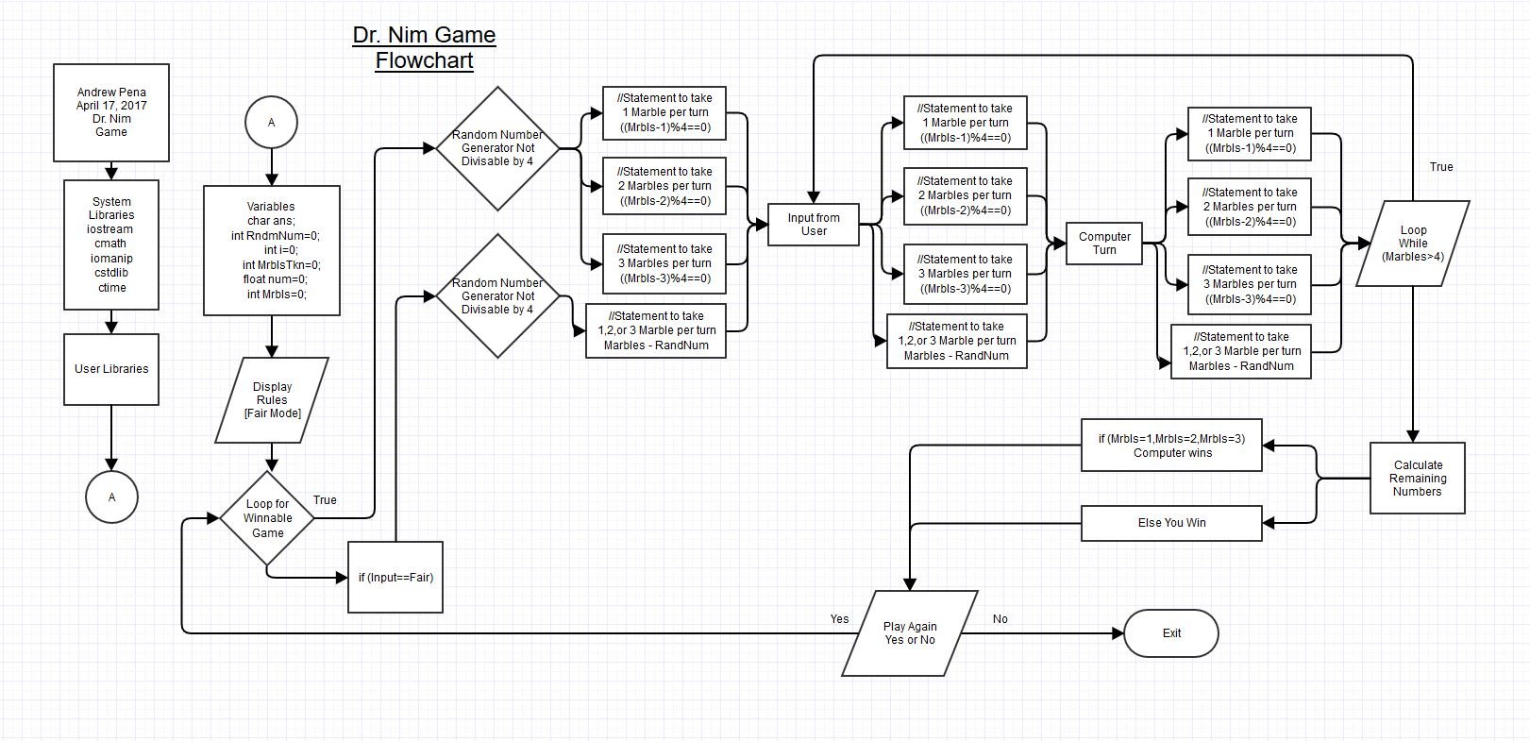
//If the user types Yes or yes the game will start again asking if you would like a fair match

